All code associated with the GUI is located in the folder mainGUI
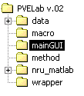
The following flow diagrams are meant to create a file dependency overview.
The flow creating the GUI:
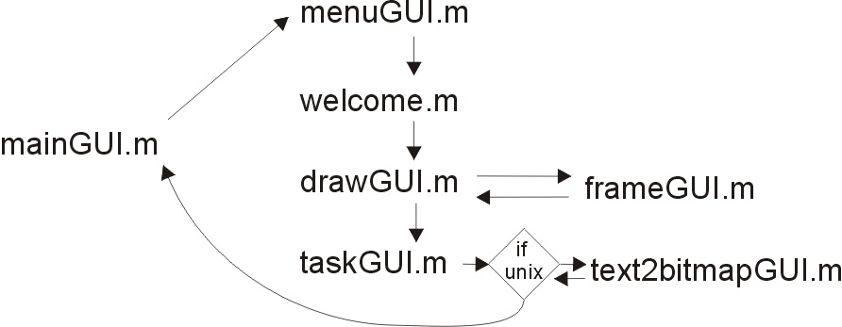
The flow of callbacks:

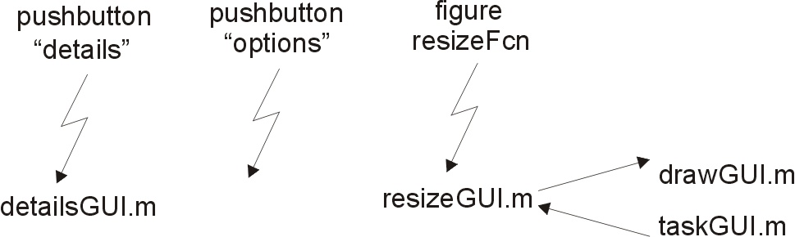

Some callbacks execute inside a file. For example taskGUI.m has some Uicontrols that have callback functions written inside the taskGUI.m file. These ‘internal’ callbacks are not shown here.

These sketches explain which GUI objects are created in the files.
Elements created in mainGUI.m

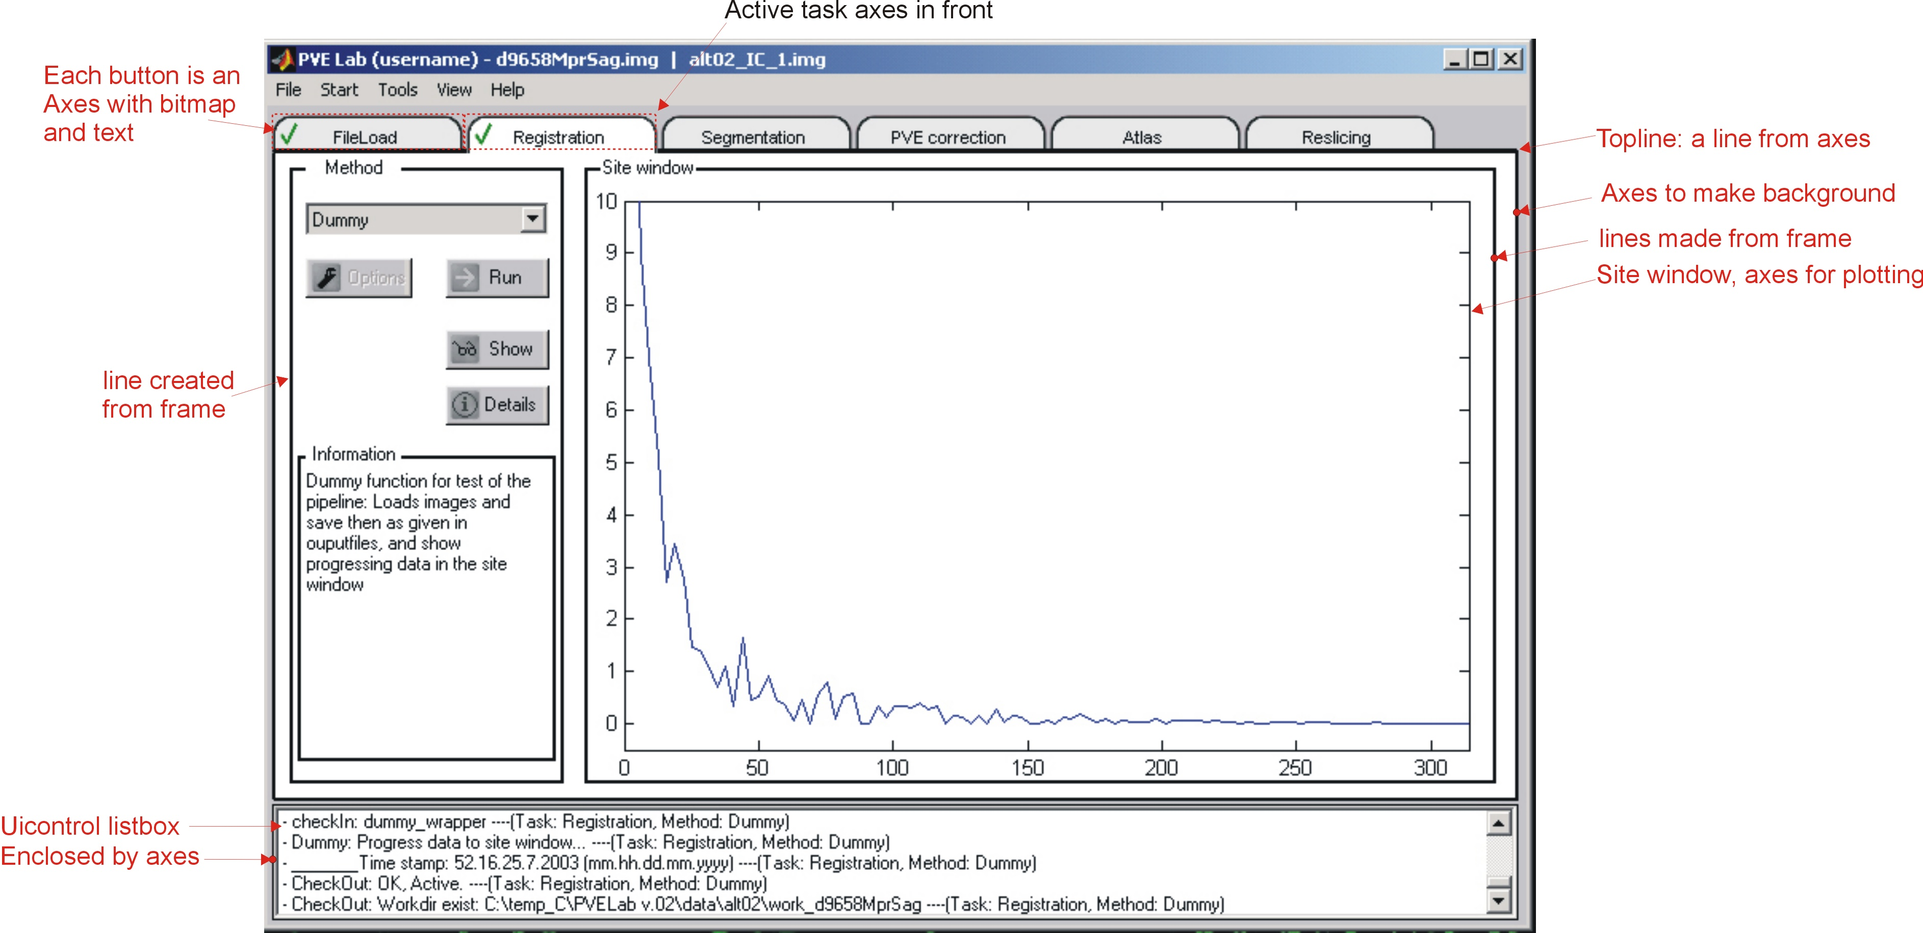

The axes that displays the active task bitmap appears in front. The effect is made by using the topline axes, which covers the task “buttons” when they are not active.

The frame objects are used in a special way bacause usually a frame can only contain Uicontrols and not axes. The frames are used to create lines, so what appears to be a frame is in fact 4 frame objects.

Elements created in taskgui.m
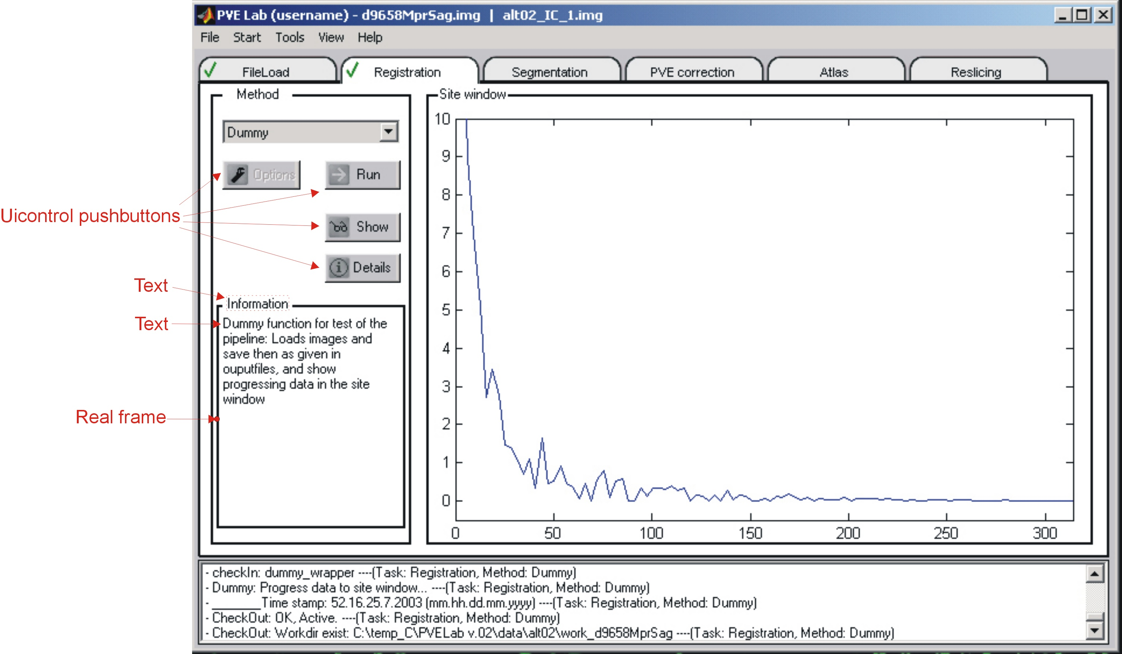

The Uicontrol pushbuttons do not behave equally under windows and linux, so some workaround had to be done. The taskGUI.m detects the OS and creates the Uicontrols different for each OS.

